Locating a lab

In Remote Systems Explorer open the following:

IFS/Root File System/IBC233Labs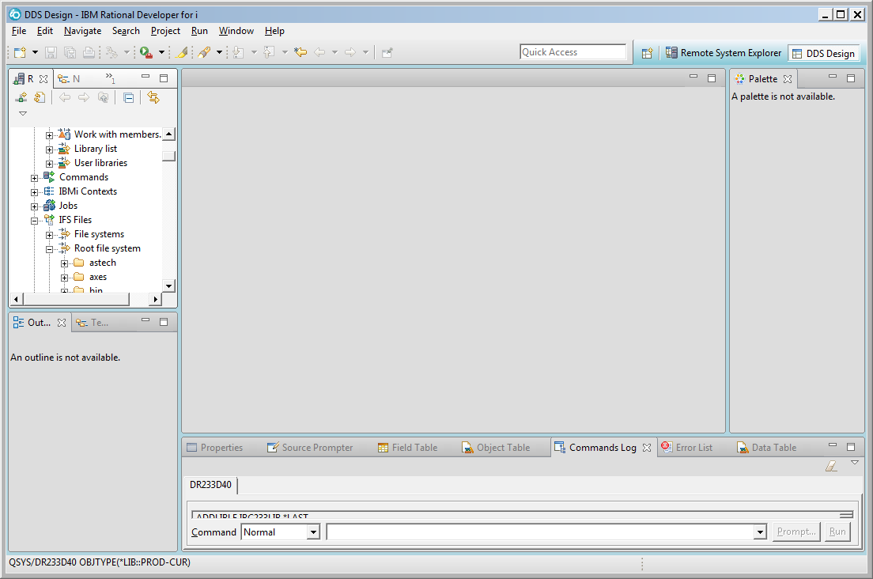

You can double click on the Remote Systems Tab to get a better picture of the route followed

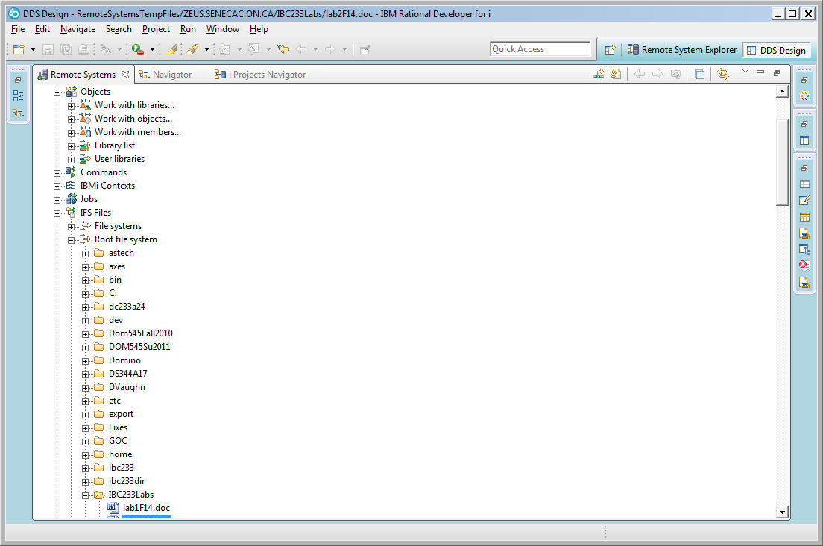

You can double click on the lab to open it up in a tabbed window. If that doesn’t work, you can right click and select open with system editor.

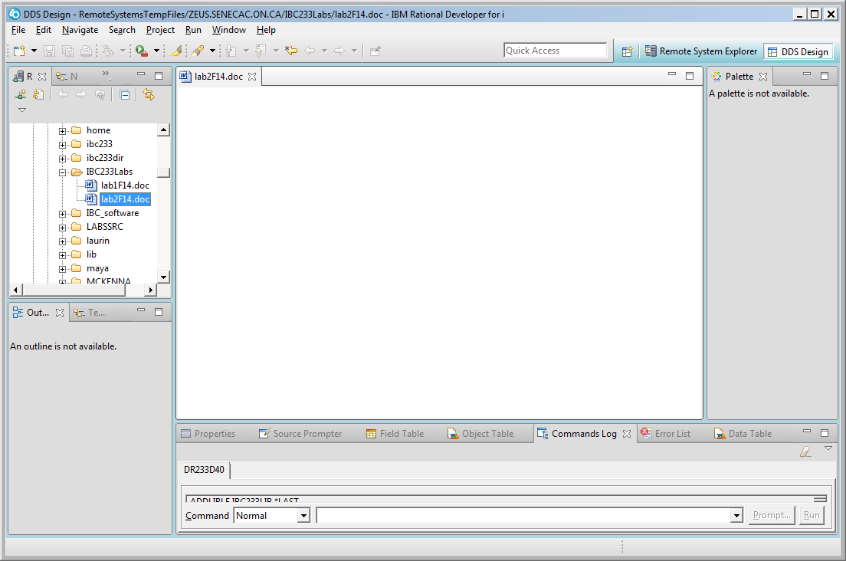

If you want a copy of the lab, you can right click and select copy. Then move up to Local Files and open up the disk drive and directory you want and select Paste. As of this printing you cannot use the paste option in windows explorer, you need to navigate with Remote Systems using the Local Files option.

